**AES MINI PROJECT**

**Name:Ravina yadav**

**Roll No. : 32**

**Subject:Msc-C.S part-1**

**Aim**: Using Arduino display temperature on LCD

**Soln**:

Step1: Open tinkercad and click on circuits and add new circuit.



Step2: Now click on search box and type name of the components needed, and drag the component on the screen.

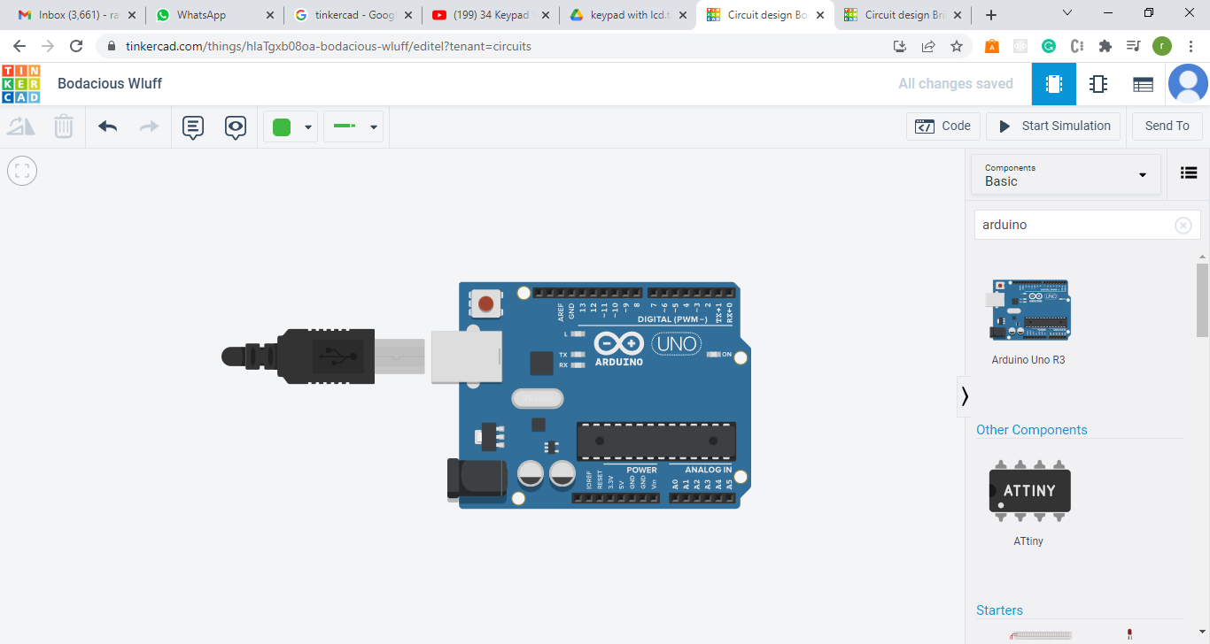

Step 3: Simillarly drag all the needed components on the screen like breadboard,LCD,potentiometer,resistor and temperature sensor like tmp36(DHT is not available tinkercad so we will use tmp36.)

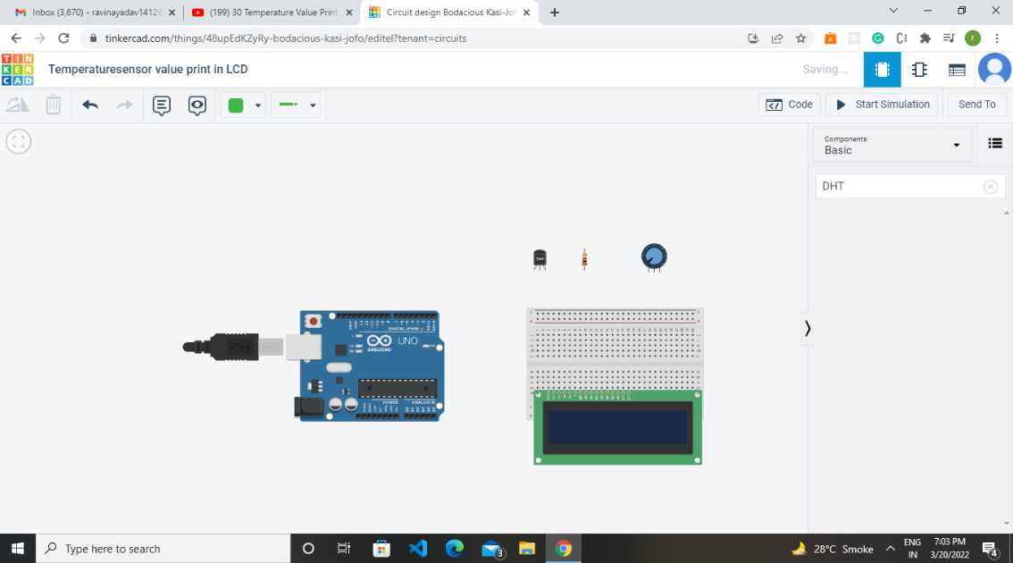

Step4:Now we need to make all the connections, ardunio LCD connection and tmp36 with ardunio.

1. Connect **5v** of ardunio with **5v** of the LCD
2. Now we will connect negative pin (GND) with **Gnd**
3. Connect potentiometer positive,negative terminal with gnd and **5v** of the LCD and connect middle of the potentiometer with the Vo pin of the LCD.
4. Connect LCD anode with the **5v** pin of the Arduino and cathode pin with resitor and the resistor with the **GND** of the Arduino.
5. **Rs** pin of the LCD with the 8 of Arduino
6. **Rw** pin with GND
7. **E** pin with **7**
8. **D4** pin the **6**
9. **D5** pin **5**
10. **D6** pin **4**
11. **D7** pin **3**
12. Now we need to connect temperature sensor, power pin of tmp36 will be connected to **vcc** of ardunio and negative pin will be connected to the **GND** of arduino.
13. And output pin will be connected to **A0** of arduino.

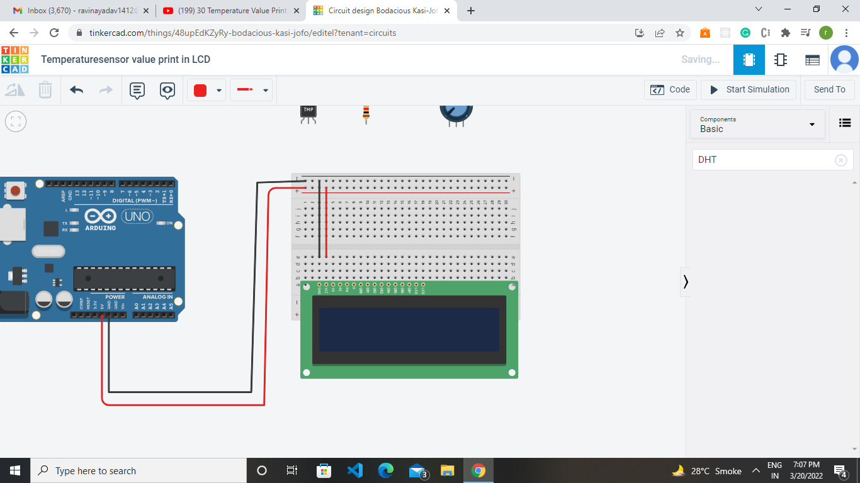

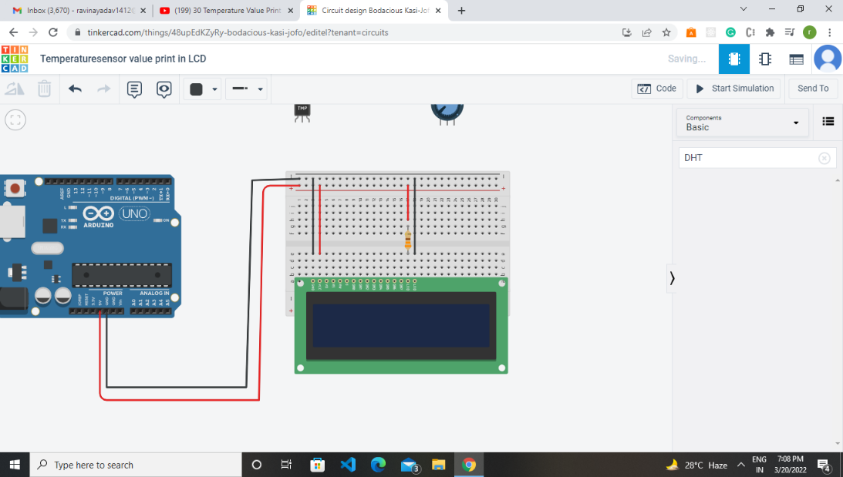

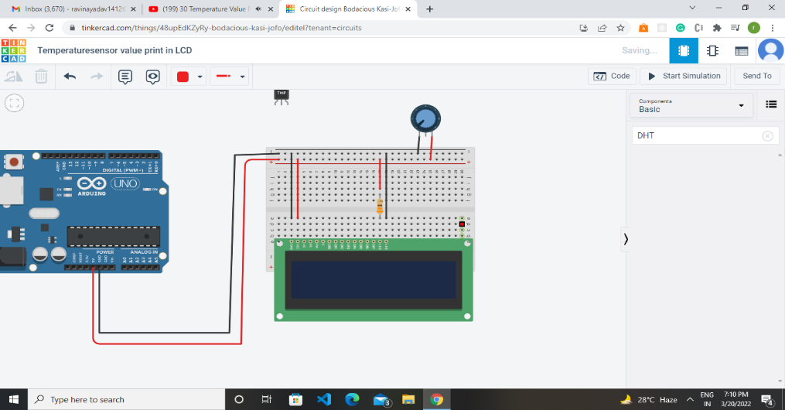

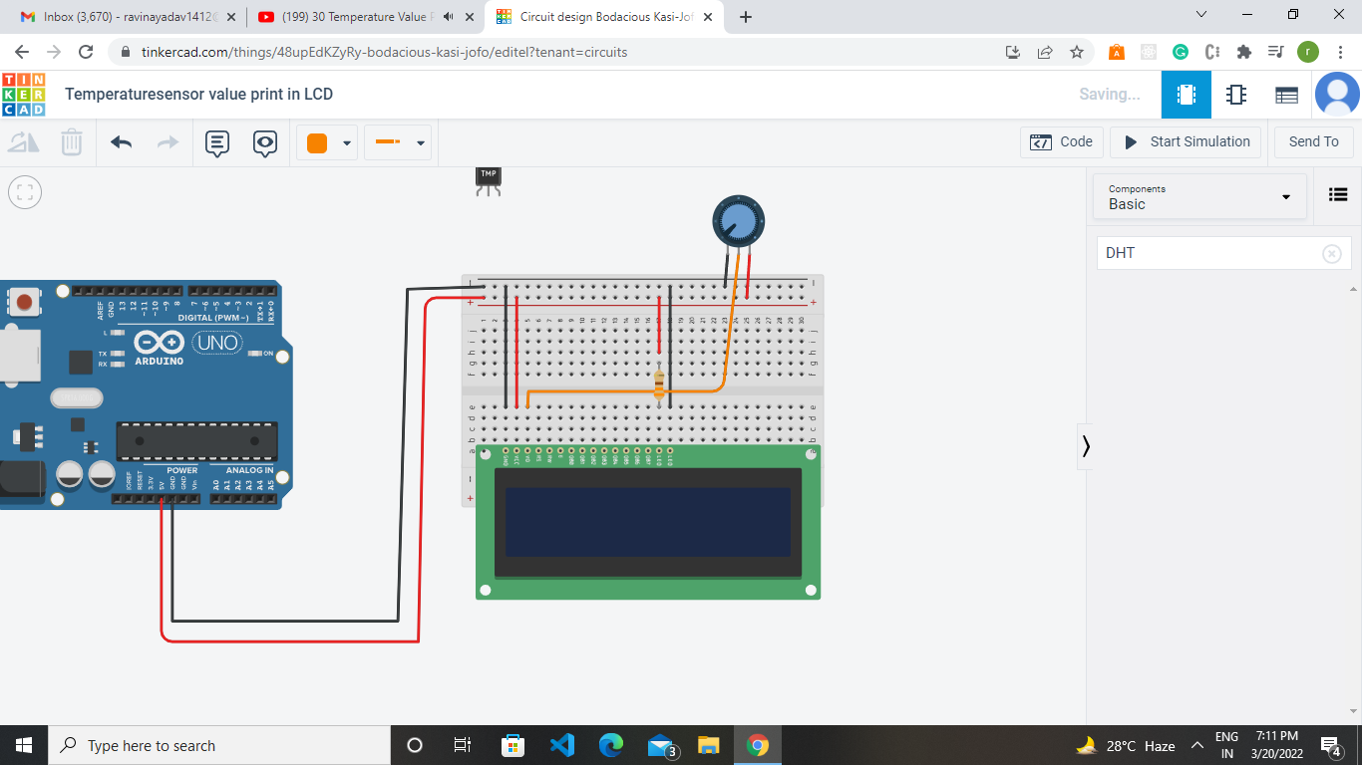

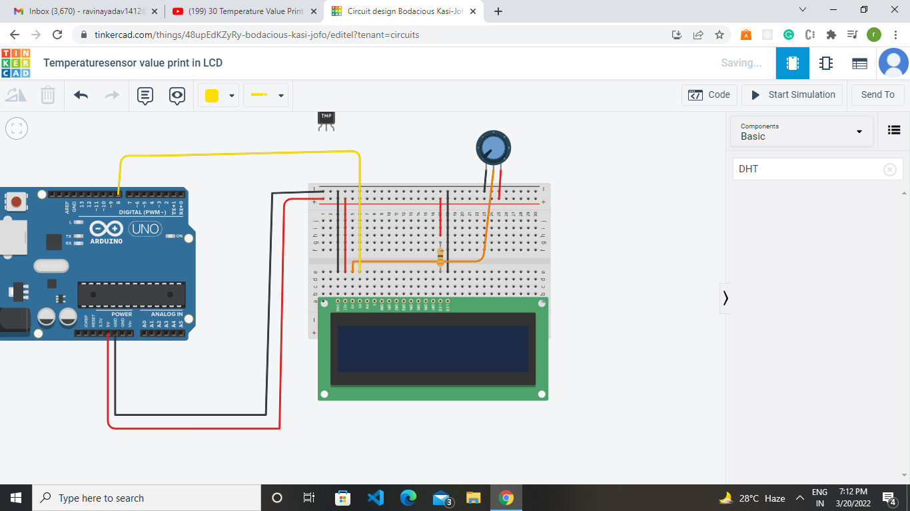

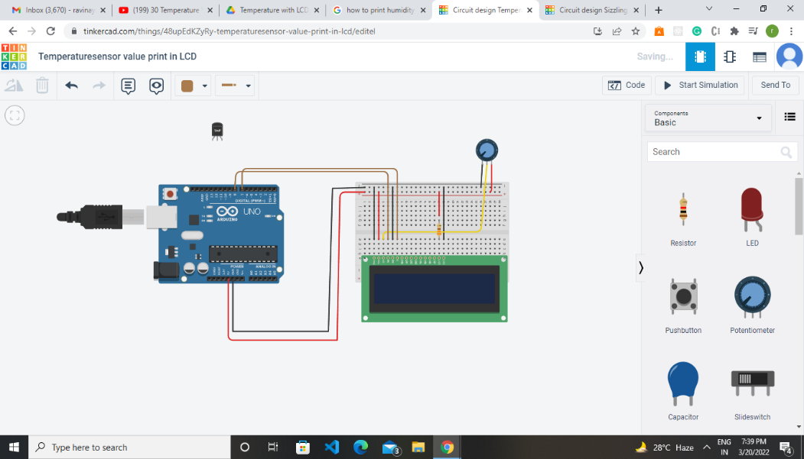

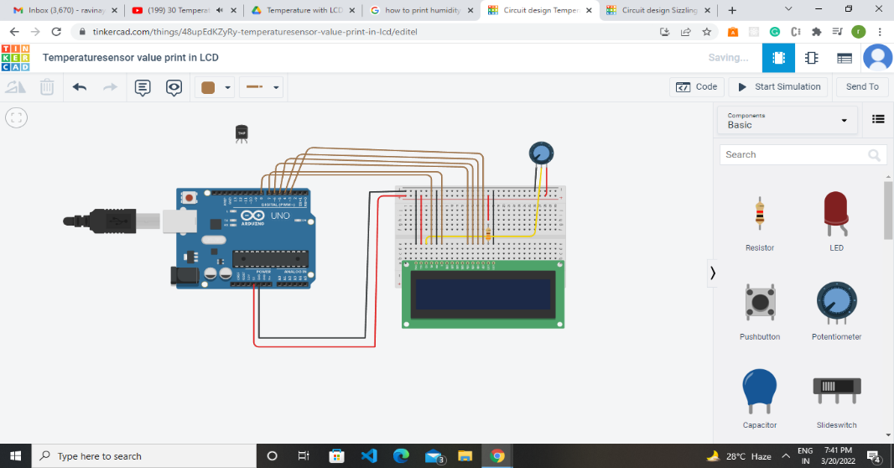

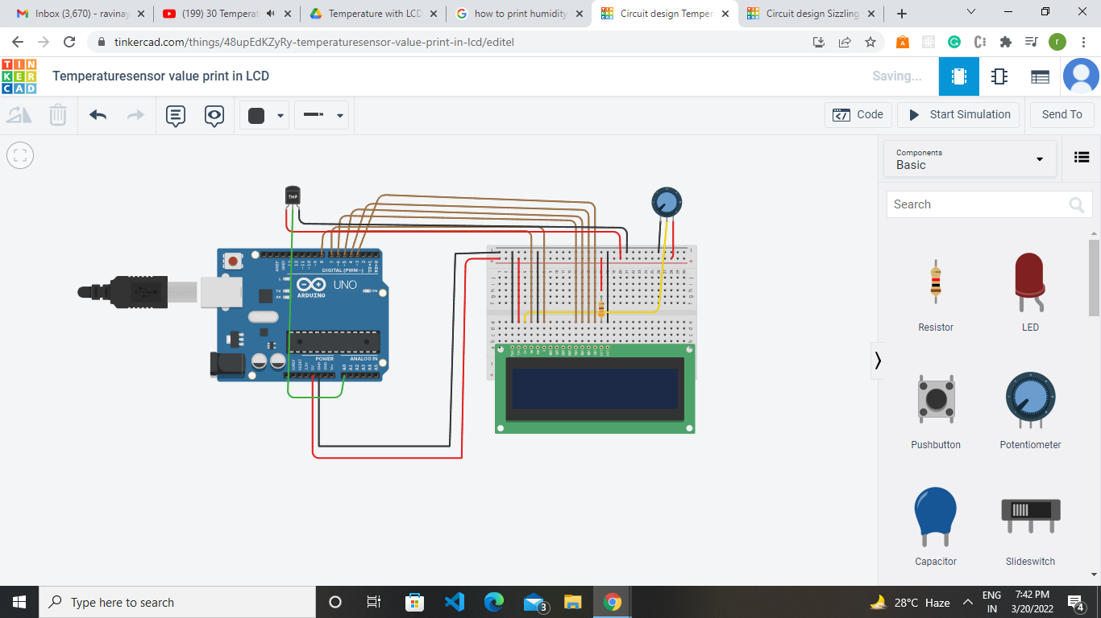

Step4.After making all the connections we need to write the code and start simulation in tinkercad.

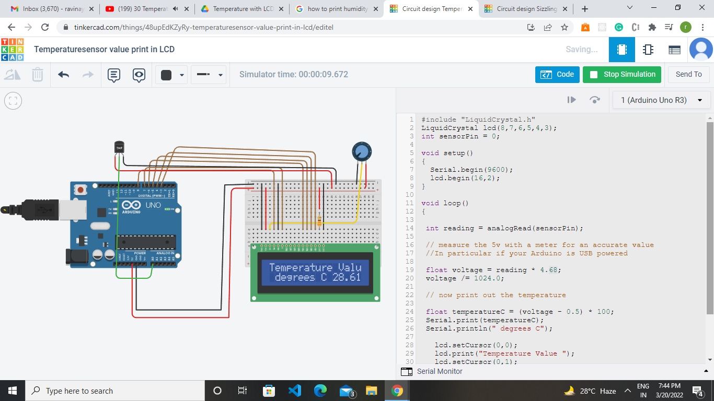

Code:

#include "LiquidCrystal.h"

LiquidCrystal lcd(8,7,6,5,4,3);

int sensorPin = 0;

void setup()

{

Serial.begin(9600);

lcd.begin(16,2);

}

void loop()

{

int reading = analogRead(sensorPin);

// measure the 5v with a meter for an accurate value

//In particular if your Arduino is USB powered

float voltage = reading * 4.68;

voltage /= 1024.0;

// now print out the temperature

float temperatureC = (voltage - 0.5) * 100;

Serial.print(temperatureC);

Serial.println(" degrees C");

lcd.setCursor(0,0);

lcd.print("Temperature Value ");

lcd.setCursor(0,1);

lcd.print(" degrees C");

lcd.setCursor(11,1);

lcd.print(temperatureC);

delay(100);

}

Output:

